**PIE CHART 1:Do you think that survey is useful to you?**

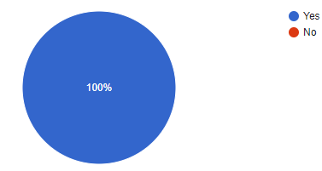

**PIE CHART 2 :Did you feel any difficulty in responding to our questions?**

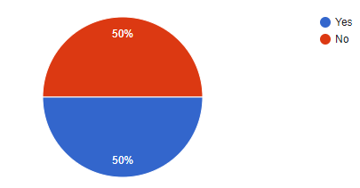

**PIE CHART 3:Did you get awareness on reuse, disposal of plastic waste used?**

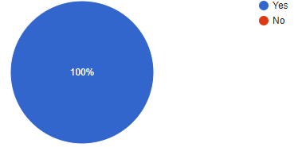

**PIE CHART 4: Did you feel that any alternative instead of using plastic after this survey?**

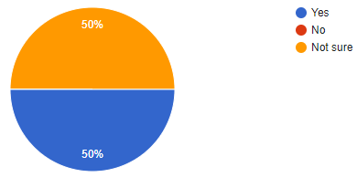

**PIE CHART 5 : How do you rate overall survey?**

